1(created a monitoring machine and target machine)

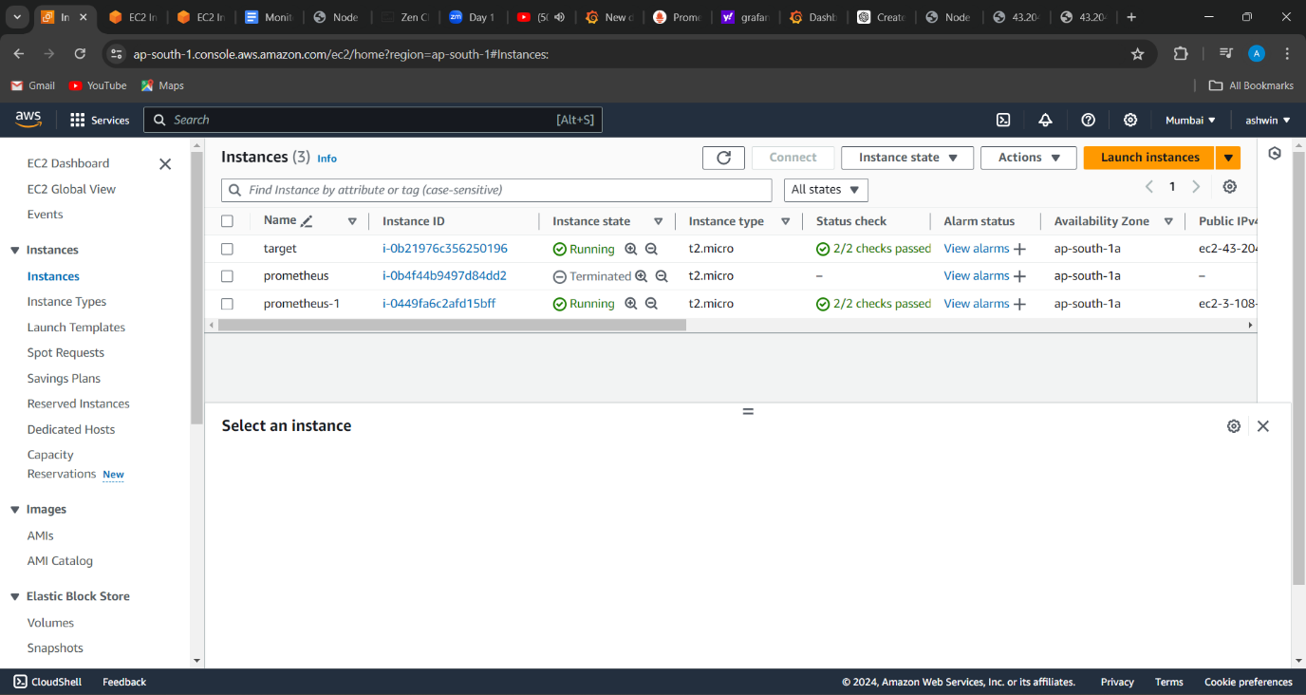

2(created promotheus in monitoring machine)

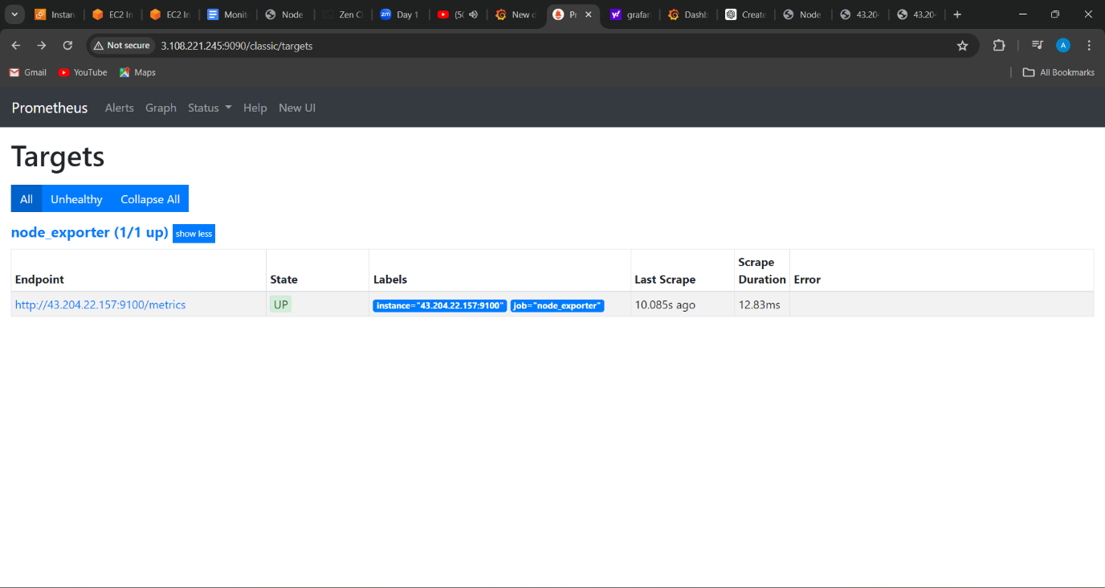

3(created grafana in monitoring machine)

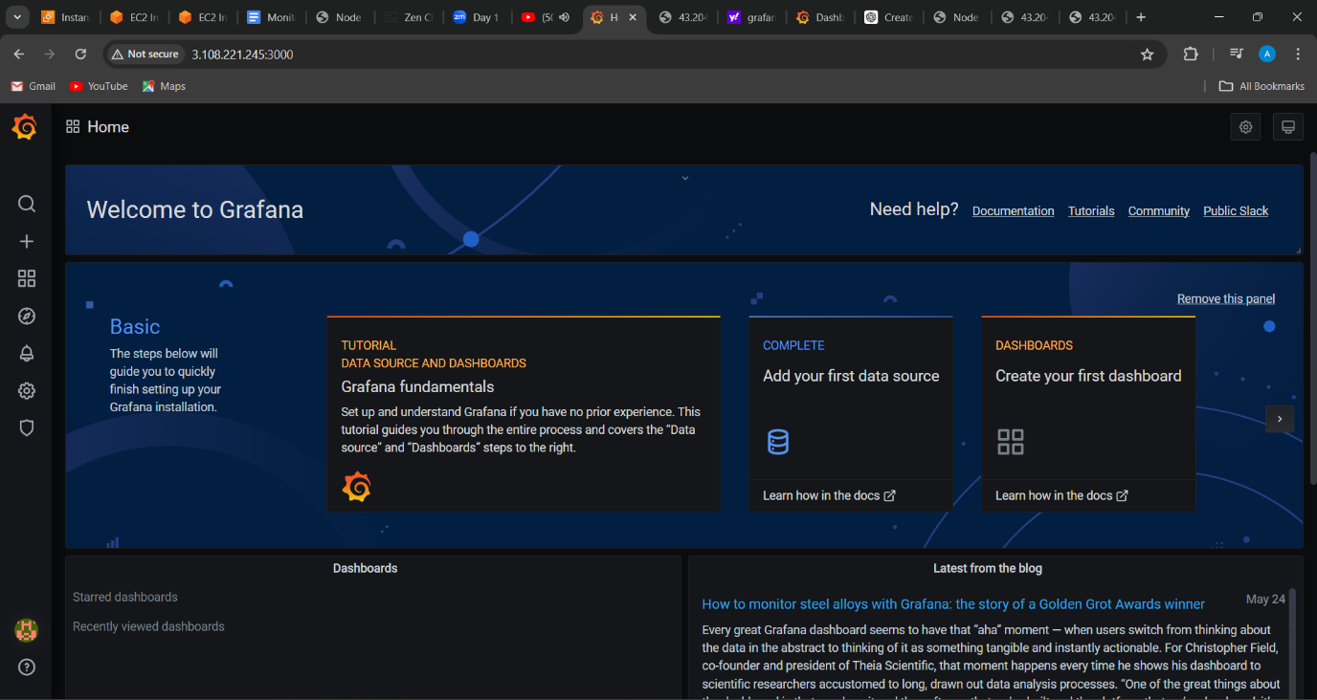

4(created node exporter in target machine)

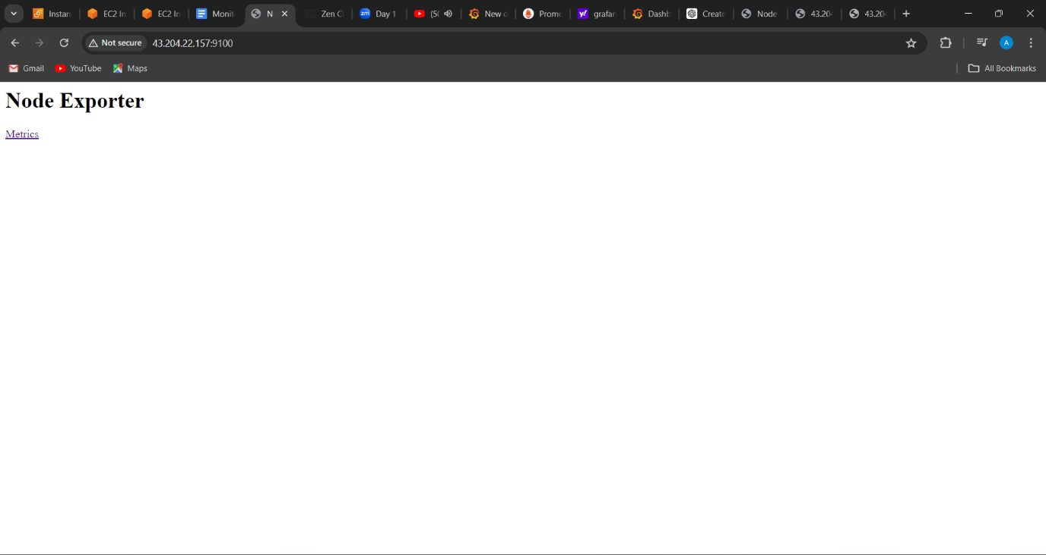

5(configured the prometheus to node port ip of target machine)

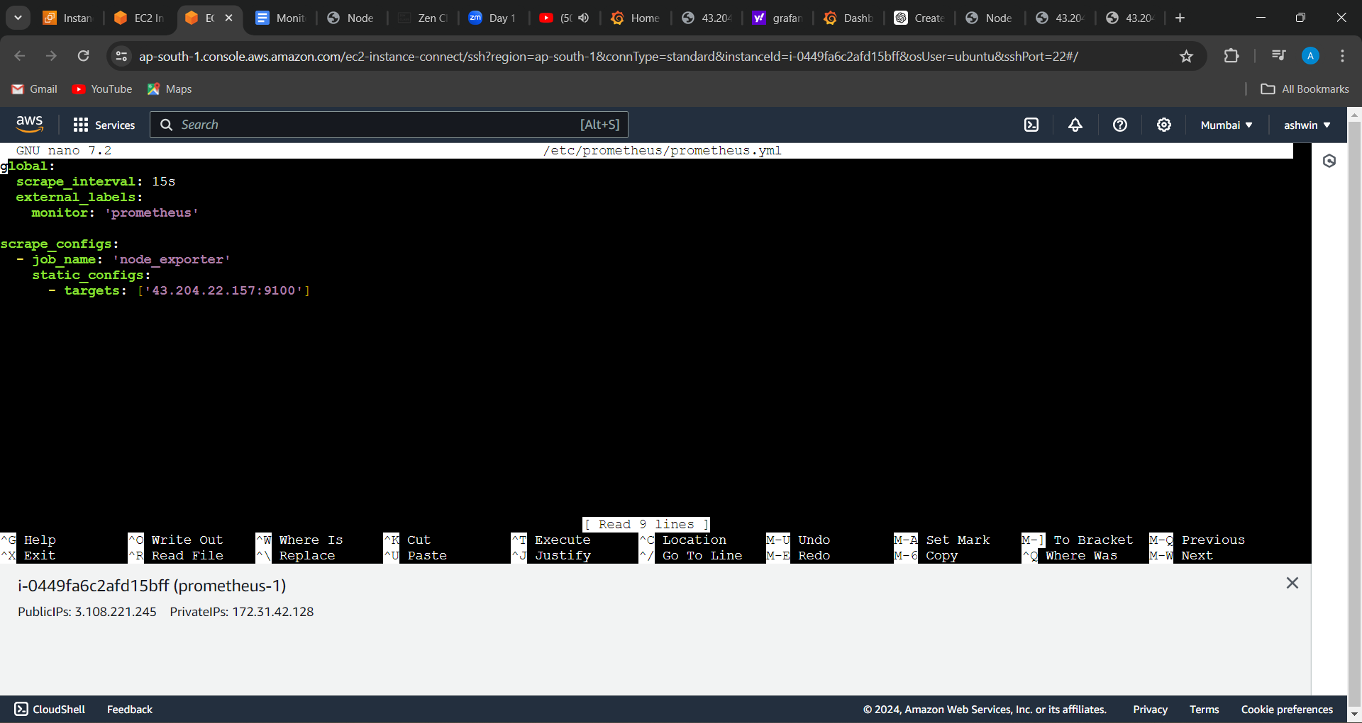

6(metrics given by prometheus )

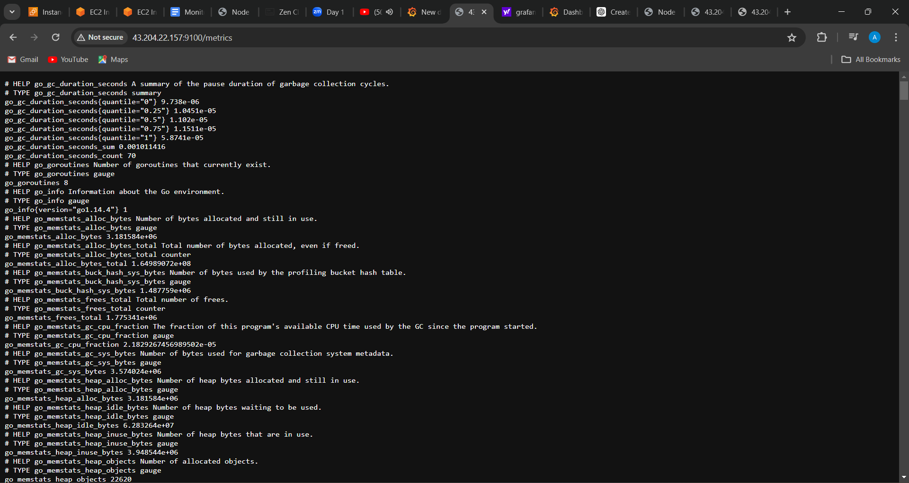

7(dashboard created in grafana to view metrics)

